American Chestnut Lab

Seeds:

Use Page5 7, 8, and 9 to identify the seeds

Container:

1________________

2________________

3 _______________

Tree Rings:

How old is this sample of American Chestnut?

Identify the earlywood and latewood

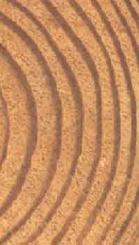

Infected?

Does this specimen of American Chestnut show any signs of the blight?

Range:

How many states once contained American Chestnut trees?

Leaves:

Trace the American Chestnut Leaf in your Notebook. If time, Trace (and label) Chestnut Oak and Chinese Chestnut as well.

Lumber Samples:
Which sample is American Chestnut? For an extra challenge, can you identify all the lumber samples?

